CO2-Assesment Tool 3

1.Debugging String Matching Code (Incorrect Match Detection Condition)
Aim
To debug and correct the brute force string matching algorithm so that a match is reported only after every character of the pattern matches successfully.
Problem Statement
The given brute force string matching program checks characters one by one. However, the match detection depends on the value of the loop variable j, which is not a safe way to determine whether the entire pattern matched. The program must be corrected so that a match is added only after all characters are successfully compared.
Algorithm
Step 1: Read the text string.
Step 2: Read the pattern string.
Step 3: Find the lengths of the text and pattern.
Step 4: Compare the pattern with every possible position in the text.
Step 5: If any character mismatches, stop checking that position.
Step 6: If all characters match, store the starting index.
Step 7: Display all matching positions.

Correct Code:
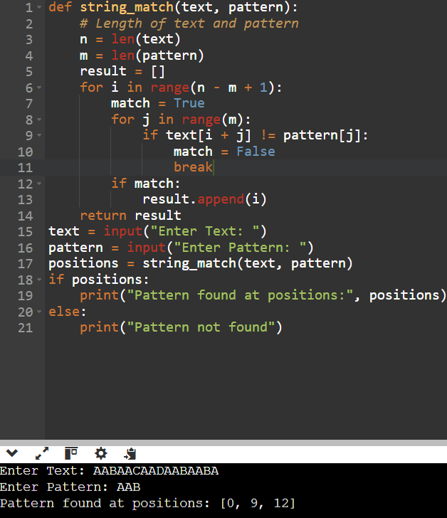

Why the Original Code Was Incorrect
Original condition:
if j == m - 1:
result. Append (i)

Problems
- It depends on the final value of j.
- The loop variable should not be used to decide whether the entire pattern matched.
- If the loop structure changes or exits unexpectedly, this logic can become unreliable.
- It is less readable and harder to maintain.

Correct Approach
Use a Boolean variable:
match = True
If any mismatch occurs:
match = False
After the loop:
if match:
result. Append(i)
This clearly indicates that every character matched successfully.
Case | Time Complexity
Best | O(n-m+1)
Average | O((n-m+1) *m)
Worst | O((n-m+1) *m)
Time Complexity:
Where:
- n = Length of the text
- m = Length of the pattern

